CSC-654 Algorithms Design & Analysis

Homework #4

Mostafa Abdelmegeed

# Question 1

# 

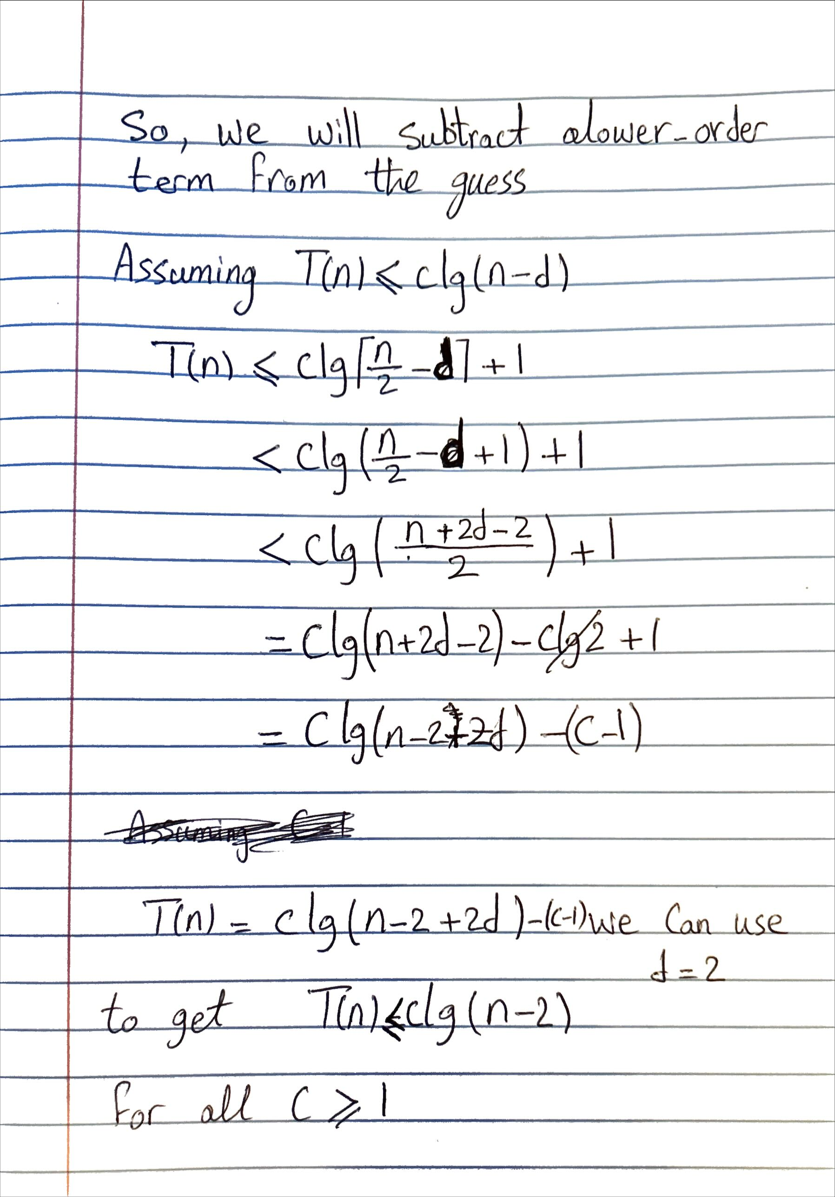

# Question 3

# Question 4

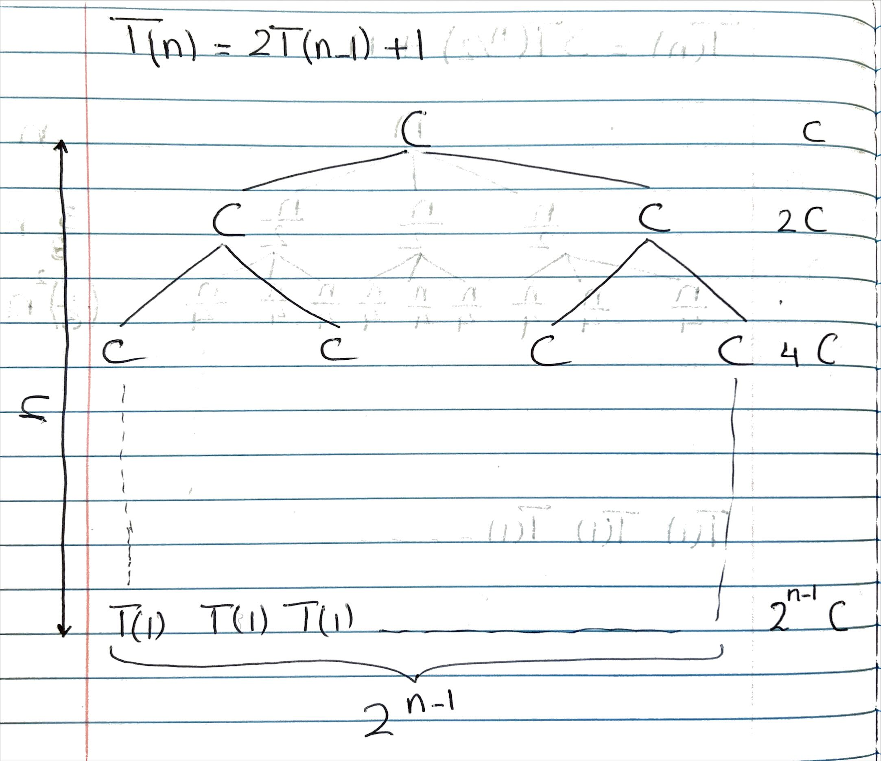

# Question 6

